Participant suggestion International Visitors Programme 2027

The visitors’ programmes, planned by the International Visitors Programme at NRW KULTURsekretariat, are announced for application once a year. For the international participants in the programme, travel, accommodation, transfer and programme costs will be covered by the NRW KULTURsekretariat.

This gives you the opportunity to propose a programme participant.

Criteria:
- The International Visitors Programme is a networking programme and not a travel grant for already
scheduled speakers or artists.
- The participation of the international guests in a substantial programme that goes beyond the occasion of the invitation (e.g. festival) is obligatory. The respective programme is developed by the applicant together with the International Visitors Programme.
- The following criteria must be taken into account when recommending international guests:
  - strong networking in the field of action in their own country and beyond
  - interest in sustainable contacts and future cooperation as well as curiosity about the cultural state of North Rhine-Westphalia
  - mastery of the English language
- The programme participants undertake to provide detailed feedback (form) for an internal evaluation after the trip.
- Journalists commit themselves to reporting; information on the publication medium is required in advance with the application.
- A direct application of the guests is not possible.

For further information and requirements, please also see the information in our FAQ (German language).
We can only consider fully completed forms.

Suggesting institution:
Contact person:

Title of the visitors’ programme:

Suggested candidate:

Ms Mr diverse Given name:
Family name:

Institution/position:

Postal address:

Email: Telephone: Website:

Language skills: English (obligatory) German Others:
Has this person previously visited NRW? no / I don’t know
yes, on this occasion:

Does the guest need a visa: no yes

Short CV:

Reasons for recommendation (e.g. possible cooperations):

Other comments (e.g. physical impairment, availability or food intolerances):

For journalists
Information on the media coverage:

Form of publication: print digital
Title:

Short description of the medium:

Language/s of publication:
Publication range (circulation, subscribers, followers, etc.):
Target group:

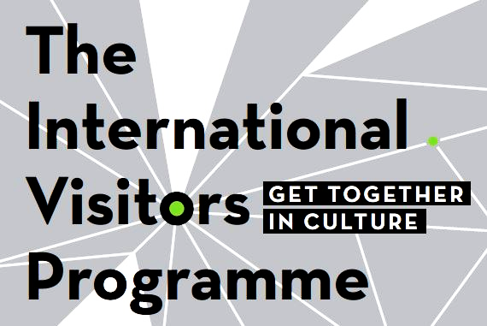
For questions, feedback and suggestions please
contact us:

Eva Lenhardt
Internationales Besucherprogramm
NRW KULTURsekretariat
Döppersberg 19
42103 Wuppertal | Germany
T: +49 (0) 202 698 27 222
lenhardt@​nrw-kultur.de

